Multicultural Legends/Folktales
by
Alex Carter & Paige Pritts

A Legend is a story that is historical in nature, but has no substance or actual facts about the events. There are legends where the historical figure exists, but are normally just stories that are based or created around that person or figure. Legends can also refer to anything that inspires stories or with lasting importance/fame and the stories are handed down but evolve over time.
A Folktale is a fictional tale about people/animals and usually tells about the creation of things or about how characters cope with everyday life which can include crisis or conflict. Folktales also communicate traditional beliefs, myths, tales, and practices and shows to be a vital part of every culture.
Common Elements of Legends
Portray historical events with exaggerated facts and contains fiction
Actual people or heroes that do good deeds (Morality)
Features cultural heroes
Appeal to Empathy
Multiple Versions of the same story
Common Elements of Folktales
Creationists stories that explain the wonders of the world
Fear of not being loved or leaving home
Good and Evil
Right and Wrong
Happiness, Friendship and Loyalty between certain characters

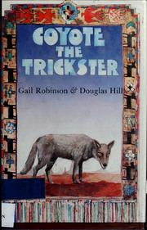
Coyote the Trickster
Author: Gail Robinson & Douglas Hill
Illustrator: Graham McCallum
Genre: North American Indian Folktale/Legend
Grade Range: Primary and Intermediate

Plot Summary: “Coyote The Trickster” contains many stories about a powerful being who uses multiple personalities and uses them to take advantage of many people in order to teach them valuable lessons. He was a supernatural being, one that usually took the form of different animals. The Trickster animal-god of the Great Plains takes the form of a Coyote and taught humans things so that they would not always be ignorant and vulnerable to the world. In the first tale (also known as an Ute tale), Coyote Steals A Blanket, Coyote wants to go through the canyon in the desert, but Hummingbird (also the voice of reason) warns Coyote that the canyon is dangerous and that he should go along the ridge. Coyote ignores Hummingbird and goes through the canyon anyway. One day, Coyote steals a beautiful blanket off a rock, but the rock was filled with spirit and chases Coyote and will not stop until he gets his blanket back. Hummingbird tells Coyote to give the blanket back, but Coyote refuses until the rock crushes his tail. Hummingbird stops the rock, but forces Coyote to return the blanket and then fluffs Coyote's tail back to fullness and tries to teach him a lesson, but Coyote will never learn.

Reader Response Activity: The tale teaches the morality of honesty and that you should never take something that does not belong to you. However, since this is a North American Indian Folktale about a spiritual being who takes the form of a coyote, it would be fun to have the students make their own coyote masks. They could customize their masks as much as they'd like, but it would maintain the shape of a coyote's head. Then they could write their own stories about honesty or a drawing.

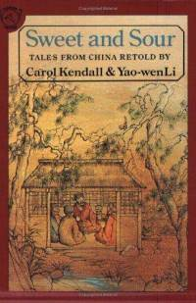
Sweet and Sour
Author: Carol Kendall & Yao-wen Li
Illustrator: Shirley Felts
Genre: Chinese Folktales
Grade Range: Primary and Intermediate

Plot Summary: “Sweet and Sour” is a collection of tales from China, that have been translated and retold. In one of the tales called Stewed, Roasted, or Live? Is a tale about two hunters, who have had no catches or game all day and were planning on going home. As they start to leave, they spot a flock of geese, and get really excited. One hunter goes on about making the geese into a stew with “soya sauce and ginger”, whine the other hunter talks about roasting the geese in “plum sauce with crackling crispy skin”. Since the hunters have two different ideas about cooking the geese, they get into an argument about how to cook the geese, and while they are arguing, the geese leave and they are left with nothing to hunt.

Reader Response Activity: Stewed, Roasted, or Live? Is a short tale, along with many other tales in the book, so it would be good to read aloud to the students, which would give better voice to the characters in the tales. It would be great to have the students, after the read aloud, to write their own tales about two people who find something they both want, but have to find a way to share it or else their item would be taken away. To prose ideas, possibly ask the students if they have ever found something that they and someone else both wanted, but had to find ways to share it.
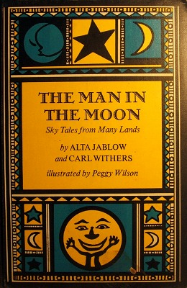

The Man In The Moon
Author: Alta Jablow and Carl Withers
Illustrator: Peggy Wilson
Genre: Folklore (variety of folklore from different cultures)
Grade Range: Primary

Plot Summary: “The Man In The Moon” is a collection of folktales about the 'man in the moon' from various cultures and regions. There are tales from Luxembourg, America, Germany, certain American Indian tribes, etcetera. One of the tales, The First Tears, a folktale from Algeria, it tells about an orphan boy, who was very sad but did not know how to weep. The moon came from the night sky down to the boy and taught him to cry, but the moon took the boys tears back with him into the sky. The moon then gave the child a blessing that all people shall love the boy. After the child cries his heart out, the moon returned to the sky and from that day forward, the orphan was happy because everyone gave him whatever they wanted and “gladdened” him. To this day, the tale says that people can see the face on the moon that are the stains from the child's tears, which were the first in the world.

Reader Response Activity: Since the book holds a variety of tales about the 'man in the moon', it would be good to have the students draw their own face or man on the moon and then create a story about how the face (or man/woman) got on the moon. This lets the children write creationist tales, which are also folktales, and allow them to let them connect more with the tales about the man in the moon.

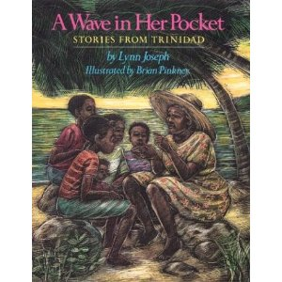
A Wave In Her Pocket
Author: Lynn Joseph
Illustrator: Brian Pinkney
Genre: Trinidad Folklore
Grade Range: Primary and Intermediate

Plot Summary: “A Wave In Her Pocket” is a collection of stories from the author who lived in Trinidad, West Africa, and write about tales about many different things in life that were told to her. By her tauntie In Trinidad, almost all families have a tauntie, who is usually a grandaunt that helps take care of the children and often gives advice to mothers. A tauntie also always has stories to tell, because anytime is story time. One of the stories, Ligahoo, is a folktale about young children who go down to the river during the rainy season to watch the water rise and descend, even though their mother and aunt told them not to. Soon, they were caught by Tauntie, who warned them about a being named Ligahoo that lived in the river, and commanded anything he wanted and that everything dangerous that happened to their town was because of him. Soon, the children became intimidated and frightened because Tauntie was telling them to close their eyes and turn away and saying Ligahoo was coming out of the river. The children did as they were told, while Tauntie went and talked to Ligahoo, speaking words like “magic” to the children who didn't know what she was saying. Afterward, the children all went home and never visited the river again, but watched from afar.

Reader Response Activity: The rivers mean a lot to the cultures of Africa, and those in Trinidad, because it provides water for drinking and farming. This story would be good for a read aloud, and then after, ask the students what else is water used for. Then have the students discuss what is important to them

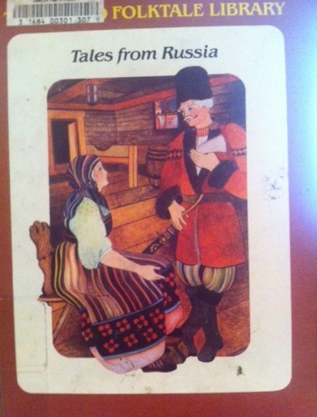
Tales from Russia
Author: Marie-J. Garczynska
Illustrator: Marie Chartrain
Genre: Russian Legends and Folklore
Grade Range: Primary and Intermediate

Plot Summary: “Tales from Russia” is a collection of different Legends and Folktales that are from Russia, retold by the author, Marie-J. Garczynska. One of the stories, Prince Ivan and the Firebird, is a Legend about Prince Ivan of Moscow who's father had a magical tree that grew golden apples. One by one the golden apples started disappearing, and Prince Ivan's father found that it was a bird of gold and fire taking his apples at night. The Czar, Ivan's father, had 3 sons and each of them took one night to watch the tree and if one of them caught the bird, they would receive half of their father's wealth. The first two brothers, Dimitri and Vissali, fell asleep at the tree and did not find the bird, but lied to their father about sleeping. Ivan, caught a feather of the bird on his watch and presented it to his father, who then sent Ivan on a journey to bring him the bird. On his journey Prince Ivan befriends a gray wolf who helps him through all his trials that Ivan encounters because he gets caught stealing the bird. After all the trials, and help from the gray wolf, he returns home with the bird, a horse with a golden mane, and Ludmilla the Beautiful, but his brothers become jealous and tie Ivan to a tree and take everything from him. The gray wolf returns and frees Ivan, who goes into the castle, explains everything to his father that had happened and gets his love, Ludmilla back. His brothers, Dimitri and Vissali disappear, but no one is sad because of the horrible things they've done.

Reader Response Activity: It is apparent that the Legend of Prince Ivan tells about how you should never steal, and to be honest and true and that will get you everything you desire. A side moral from this Russian tale is that if you do bad things, you will not be missed. This story would be a good read aloud, and maybe afterward, have the students connect to the other stories where the hero goes through trials to achieve his goal, (such as Hercules) and then let the students write their own story, that follows similar plot lines.

