Paige Pritts
Journal 1
Kindergarten
CTA Freedom
Service Learning Journal:
- The students all seem comfortable in the classroom with the teacher; they all seem to act themselves which at times isn’t good. The students still need to work on self discipline.
- The students reacted very well to me. I am a teacher figure in their eyes, and that is what my mentor teacher wanted. They all listen very well to me when I instruct them to do things.
- My first impressions were that the kids are very “out of control” when it comes to a classroom setting. Not many listen very well and she has many “islands” which are kids who sit alone, and not in a row to keep them focused and not distracting the other students.
- I feel very comfortable in my setting, I read books to the kids quite often and have taught two lessons already. They all work very well and listen when I am instructing them. I have a great passion for this so it all comes very easily to me.
- My mentor teacher is very good at using visual and auditory skills. When they do their spalding flashcards, she holds up the cards while repeating the sounds to the kids and then they repeat them back to her. They learn the sounds and alphabet so much quicker in doing so. I feel like the visual and auditory together really help the kids learn and be more successful.

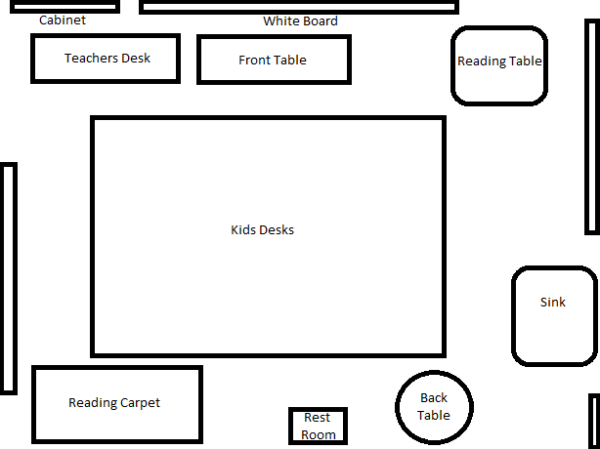
- The classroom rules are typical across the board with most kindergarten classrooms. Listen to the teacher, raise your hand, no interrupting other students or the teacher, respect your fellow peers, etc. If the students do not listen to these rules then the teacher talks to the parents, sends them to the principal, takes away free time or recess. My mentor teacher also has this system; they all come in the beginning of the day and start off with three stars, if the student breaks any of the rules through-out the day then the teacher takes away a star. At the end of the day depending on how many starts you have, that reflects how much free time you have and if you got a cone through-out the day on your desk then you also receive a sticker at the end of the day.
- When papers are passed out or collected the “Helpers” for the day are the ones who collect those, you must always raise your hand in order to leave the classroom or use the restroom. Every day they come in and start working on their morning work that is on their desk, and then they start on with their day. The teacher has a routine everyday they go through and that way they are never confused or don’t know what they will be doing. It helps the kids a lot keep track and not get overwhelmed.
- Through-out these first half hours of my service learning I helped a lot around the classroom. I read book and followed each of them with a worksheet I went through with the class and helped them complete. I helped the teacher with decorating and completing her room for the holidays. I learned that I absolutely love kindergarten and I honestly cant wait until I get my own classroom. It is going to be so fun to decorate and the kids adore you at this age. They all have some discipline issues they need to work on but in the end they will always love you and remember you. The one thing I might struggle with as a new teacher is getting evaluated; this makes me nervous because I feel that with the older people they judge me more, but if I mess up with younger children they either don’t catch on or just laugh about it. That’s why it will be easier to teach with the little ones.

